SEC Form 3
FORM 3 | UNITED STATES SECURITIES AND EXCHANGE COMMISSION  Washington, D.C. 20549  INITIAL STATEMENT OF BENEFICIAL OWNERSHIP OF SECURITIES  Filed pursuant to Section 16(a) of the Securities Exchange Act of 1934  or Section 30(h) of the Investment Company Act of 1940
  OMB APPROVAL
  OMB Number: | 3235-0104
  Estimated average burden
  hours per response: | 0.5
1. Name and Address of Reporting Person*  (Street) | 2. Date of Event Requiring Statement (Month/Day/Year)  09/24/2026 | 3. Issuer Name and Ticker or Trading Symbol  ACUITY INC. (DE) [ AYI ]  Foreign Trading Symbol
  Tzitzon Nicholas
  (Last) | (First) | (Middle)
  C/O ACUITY INC.
  1170 PEACHTREE STREET, NE, SUITE 1200
  ATLANTA | GA | 30309
  (City) | (State) | (Zip)
 |  | 4. Relationship of Reporting Person(s) to Issuer  (Check all applicable) | 5. If Amendment, Date of Original Filed (Month/Day/Year)
   | Director |  | 10% Owner
   | Officer (give title below) |  | Other (specify below)
6. Individual or Joint/Group Filing (Check Applicable Line)
Form filed by One Reporting Person
Form filed by More than One Reporting Person

Table I - Non-Derivative Securities Beneficially Owned
1. Title of Security (Instr. 4) | 2. Amount of Securities Beneficially Owned (Instr. 4) | 3. Ownership Form: Direct (D) or Indirect (I) (Instr. 5) | 4. Nature of Indirect Beneficial Ownership (Instr. 5)
Table II - Derivative Securities Beneficially Owned
(e.g., puts, calls, warrants, options, convertible securities)
1. Title of Derivative Security (Instr. 4) | 2. Date Exercisable and Expiration Date (Month/Day/Year) |  | 3. Title and Amount of Securities Underlying Derivative Security (Instr. 4) |  | 4. Conversion or Exercise Price of Derivative Security | 5. Ownership Form: Direct (D) or Indirect (I) (Instr. 5) | 6. Nature of Indirect Beneficial Ownership (Instr. 5)
1. Title of Derivative Security (Instr. 4) | Date Exercisable | Expiration Date | Title | Amount or Number of Shares | 4. Conversion or Exercise Price of Derivative Security | 5. Ownership Form: Direct (D) or Indirect (I) (Instr. 5) | 6. Nature of Indirect Beneficial Ownership (Instr. 5)
Explanation of Responses:
Remarks:
No securities are beneficially owned.
 | /s/ Chanda Kirchner, Attorney-in-Fact for Nicholas J. Tzitzon | 09/28/2026
 | ** Signature of Reporting Person | Date
Reminder: Report on a separate line for each class of securities beneficially owned directly or indirectly.
* If the form is filed by more than one reporting person, see Instruction 5 (b)(v).
** Intentional misstatements or omissions of facts constitute Federal Criminal Violations See 18 U.S.C. 1001 and 15 U.S.C. 78ff(a).
Note: File three copies of this Form, one of which must be manually signed. If space is insufficient, see Instruction 6 for procedure.
Persons who respond to the collection of information contained in this form are not required to respond unless the form displays a currently valid OMB Number.
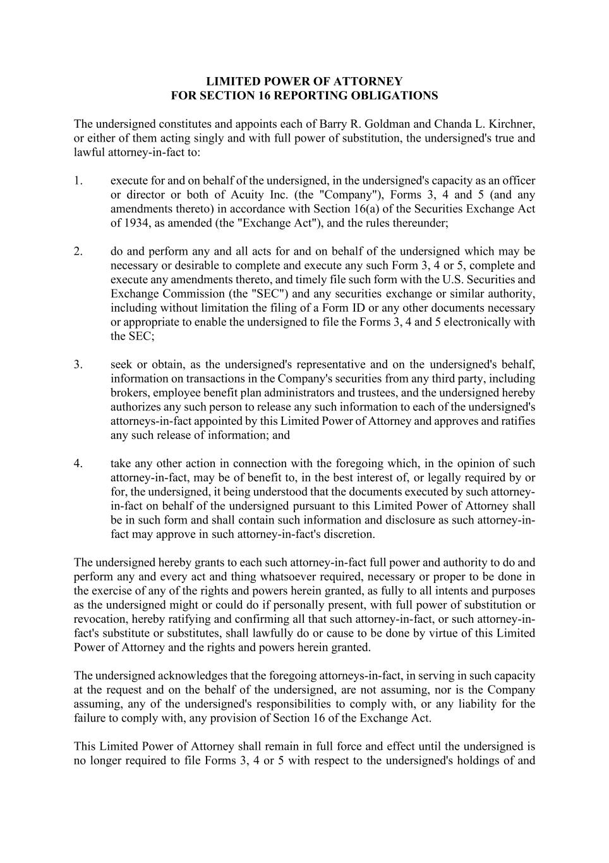
LIMITED POWER OF ATTORNEY FOR SECTION 16 REPORTING OBLIGATIONS The undersigned constitutes and appoints each of Barry R. Goldman and Chanda L. Kirchner, or either of them acting singly and with full power of substitution, the undersigned's true and lawful attorney-in-fact to: 1. execute for and on behalf of the undersigned, in the undersigned's capacity as an officer or director or both of Acuity Inc. (the "Company"), Forms 3, 4 and 5 (and any amendments thereto) in accordance with Section 16(a) of the Securities Exchange Act of 1934, as amended (the "Exchange Act"), and the rules thereunder; 2. do and perform any and all acts for and on behalf of the undersigned which may be necessary or desirable to complete and execute any such Form 3, 4 or 5, complete and execute any amendments thereto, and timely file such form with the U.S. Securities and Exchange Commission (the "SEC") and any securities exchange or similar authority, including without limitation the filing of a Form ID or any other documents necessary or appropriate to enable the undersigned to file the Forms 3, 4 and 5 electronically with the SEC; 3. seek or obtain, as the undersigned's representative and on the undersigned's behalf, information on transactions in the Company's securities from any third party, including brokers, employee benefit plan administrators and trustees, and the undersigned hereby authorizes any such person to release any such information to each of the undersigned's attorneys-in-fact appointed by this Limited Power of Attorney and approves and ratifies any such release of information; and 4. take any other action in connection with the foregoing which, in the opinion of such attorney-in-fact, may be of benefit to, in the best interest of, or legally required by or for, the undersigned, it being understood that the documents executed by such attorney- in-fact on behalf of the undersigned pursuant to this Limited Power of Attorney shall be in such form and shall contain such information and disclosure as such attorney-in- fact may approve in such attorney-in-fact's discretion. The undersigned hereby grants to each such attorney-in-fact full power and authority to do and perform any and every act and thing whatsoever required, necessary or proper to be done in the exercise of any of the rights and powers herein granted, as fully to all intents and purposes as the undersigned might or could do if personally present, with full power of substitution or revocation, hereby ratifying and confirming all that such attorney-in-fact, or such attorney-in- fact's substitute or substitutes, shall lawfully do or cause to be done by virtue of this Limited Power of Attorney and the rights and powers herein granted. The undersigned acknowledges that the foregoing attorneys-in-fact, in serving in such capacity at the request and on the behalf of the undersigned, are not assuming, nor is the Company assuming, any of the undersigned's responsibilities to comply with, or any liability for the failure to comply with, any provision of Section 16 of the Exchange Act. This Limited Power of Attorney shall remain in full force and effect until the undersigned is no longer required to file Forms 3, 4 or 5 with respect to the undersigned's holdings of and

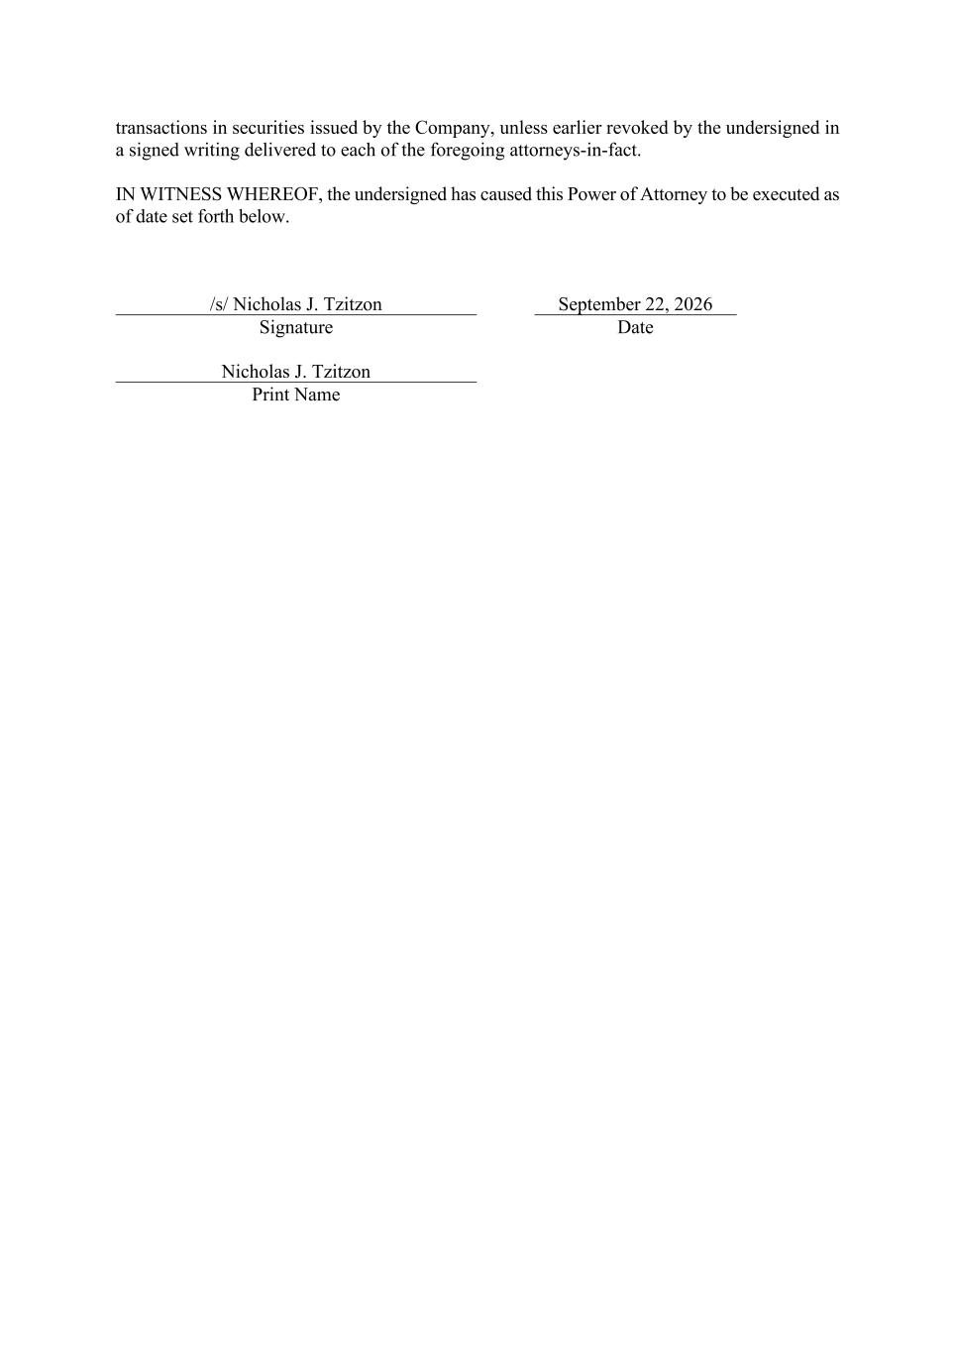
transactions in securities issued by the Company, unless earlier revoked by the undersigned in a signed writing delivered to each of the foregoing attorneys-in-fact. IN WITNESS WHEREOF, the undersigned has caused this Power of Attorney to be executed as of date set forth below. /s/ Nicholas J. Tzitzon September 22, 2026 Signature Date Nicholas J. Tzitzon Print Name

